CHAPTER – 1

INTRODUCTION
About the project:

In this project, Artificial Intelligence (AI) has recently advanced the state-of-art results in an ever-growing number of domains. The rapid advancement of technology has transformed public service delivery, with e-government emerging as a pivotal approach to enhance citizen engagement and streamline government processes. By leveraging Natural language Processor NLP deep learning & data analytics through proposed system aims to generate concise and accurate abstracts from government documents, reports, citizen queries. This process involves data pre-processing, feature extraction, semantic analysis and summarization that are generated revelant & actionable. It was faces the several challenges that deployment in the E-government & applications for both improving the e-government citizens interactions. we address the challenges of e-government systems and propose a framework that utilizes AI technologies to automate and facilitate e-government services.

CHAPTER – 2

SYSTEM ANALYSIS

2. Existing System:
Recently, many countries have adopted e-government services in various departments and various applications. In Contrast of implementing the e-government system still faces several challenges.Trusting online services depends heavily on a couple of factors including the citizens trust in the government & the quality of the online services and personal believes. Lack of experts implementing high quality online services requires the establishment of right team of experts that covers all involved practice areas from web development to security and privacy. In-accessibility of several third countries still face significant issues on accessing the internet and its services. Security has a state-of-the-art & government applications and the citizens privacy. Reliability of information have citizens may not to disc-ern between accurate information which could leads to public opinions.

2.1 Drawbacks:

- Lack of experts: lack of experts" refers to a situation where there are insufficient numbers of qualified or knowledgeable individuals in a specific field or area of expertise. This could mean that there are not enough people with the necessary skills, experience, or training to handle certain tasks, solve complex problems, or provide specialized advice.

- In-accessibility: it refers to the condition of being difficult or impossible to access, use, or reach. Inaccessibility can result in exclusion, marginalization and unequal opportunities for individuals or groups.

- Security: it involves creating conditions or systems that help ensure stability, safety, and the prevention of risks. it refers to the state of being free from danger, harm, or threat.

- Reliability of information: The reliability of information refers to the trustworthiness, accuracy, and consistency of the data or content being provided. It indicates whether the information is dependable and can be counted on to be correct and credible.

- High Maintenance Costs: refer to the expenses incurred to keep a system, infrastructure, or equipment in proper working condition over time. These costs can arise from various factors and can have a significant impact on the overall financial performance of a business or organization.

2.2 Proposed System:

It involves leveraging ML algorithms to process large datasets, predict trends, and automate bureaucratic processes. India’s DigiLocker uses ML for document verification and authentication. China’s Smart Cities implement AI-driven public safety monitoring and service automation. we first outline a framework for the management of e-government information resources. Second, we develop a set of deep learning models that aim to automate several e-government services. Third, we propose a smart e-government platform architecture that supports the development and implementation of AI applications of e-government.

2.2.1Advantages:

- Decision making : It involves identifying a problem opportunity, gathering information, considering various options, evaluating potential outcomes, and choosing the best solution or action.

- Enhanced collaboration : Enhanced collaboration refers to improved teamwork and cooperation among individuals, groups, or organizations to achieve common goals more effectively and efficiently.

- Fraud detection : It refers to the process of identifying and preventing fraudulent activities or behaviors, such as deception, theft, or financial misconduct, in various systems or transactions.

- Faster service delivery : It refers to providing goods, services, or solutions to customers or clients in a quicker, more efficient manner, without sacrificing quality.

2.3 Module Description:
My project contain Five Modules:
- Upload Insurance Dataset
- Explore Insurance Dataset
- Run Machine Learning Algorithm
- Predict BMI Based Insurance Charges
- Predicts Sentiments on Insurance

1. Upload Insurance Dataset:
In this module, we are uploading the labelled data set for purpose of trained the machine based on our input data to generating the output. To train the machine we are using TWO datasets.

- Trained dataset : In this dataset, we are training the machine based on particular input as particular output.
- Test dataset : Test dataset are used for trained dataset and rectifying the failed test cases of trained dataset.

2. Explore Insurance dataset :
In this module, we are pre-processing the dataset (or) clean the dataset and removing the missing futures (or) missing input of given labelled datasets.

3. Run Machine Learning Algorithm :
In this module, we are training the machine for our required algorithm to feteching the better accuracy of output. By using, machine learning we are increasing the auto machine process and reducing the time complexity of predicting the output in various user given fields.
4. Predict BMI Based Insurance Charges (BODY MASS INDEX):
In this module, we are predicting the BMI for their habits where assigning the insurance charges for that particular BMI person.
5. Predict Sentiments On Insurance :
In this module, we are taking the sentiments of users for that particular action that we are perform in previous module.
The sentiments are analyzed in true TWO criteria
- Positive
- Negative
2.4 Feasibility Study :
Model Testing:
After the model training is complete, and it is understood that the model shows the right result, it can be saved by:
model. save(“name_of_file.h5”).
Model Evaluation:
Finally, the saved model can be used in the real world. The name of this phase
The feasibility of the project is analyzed in this phase and business proposal is put forth with a very general plan for the project and some cost estimates. During system analysis the feasibility study of the proposed system is to be carried out. This is to ensure that the proposed system is not a burden to the company. For feasibility analysis, some understanding of the major requirements for the system is essential.

Three key considerations involved in the feasibility analysis are
- Economical Feasibility

- Technical Feasibility
- Social Feasibility
2.4.1 Economical Feasibility:
This study is carried out to check the economic impact that the system
have on the organization. The amount of fund that the company can pour into the research and development of the system is limited. The expenditures must be justified. Thus the developed system as well within the budget and this was achieved because most of the technologies used are freely available. Only the customized products had to be purchased.

    - Technical Feasibility
This study is carried out to check the technical feasibility, that is, the tec
requirements of the system. Any system developed must not have a high demand on the available technical resources. This will lead to high demands on the available technical resources.

    - Social Feasibility
The aspect of study is to check the level of acceptance of the system by user. This includes the process of training the user to use the system.

CHAPTER - 3
REQUIREMENT ANALYSIS

3.1 HARDWARE SYSTEM REQUIREMENTS:
- Processor : Intel(i3) or Ryzen(3)

- RAM : 4GB (OR) Above

- Storage : Hard disk 500GB

SSD 256GB

3.2 SOFTWARE SYSTEM REQUIREMENTS:
- Operating system : Windows 7 (or) above
- Programming Language : Python
- Frame work : Windows Based Application (T-kinter)
- Backend : Datasets

3.3 functional Requirements:
- Data owner can maintain the details and he can add, delete and update the files.
- Data owner uploads the files and makes them available to user.
- Admin generates a schedule and sends it to the user.
- Admin can maintain the details of number of users and the downloaded data.
- User can register in the site and get a login-id and password.
- With the login details the customer login into the cloud and check for available files.
- User will enter the details of filename, and may download the file after registering in the site.
3.4 Non-functional Requirements:
- Reliability :
Reliability is improved if multiple redundant users register into database,which makes well-designed cloud computing suitable for business continuity and disaster recovery.
- Performance :
Performance is monitored and consistent and loosely coupled architectures are constructed using cloud services as the system interface.

- Security :
Security could improve due to centralization of data, increased security-focused resources, etc., but concerns can persist about loss of control over certain sensitive data, and the lack of security for stored kernels. Security is often as good as or better than other traditional systems, in part because providers are able to devote resources to solving security issues that many customers cannot afford. However, the complexity of security is greatly increased when data is distributed over a wider area or greater number of devices and in multi-tenant systems that are being shared by unrelated users. In addition, user access to security audit logs may be difficult or impossible. Private cloud installations are in part motivated by users' desire to retain control over the infrastructure and avoid losing control of information security.
- Maintenance :
Cloud computing applications is easier, because they do not need to be installed on each user's computer and can be accessed from different places.

CHAPTER –4

SYSTEM DESIGN

4.1 System Architecture:

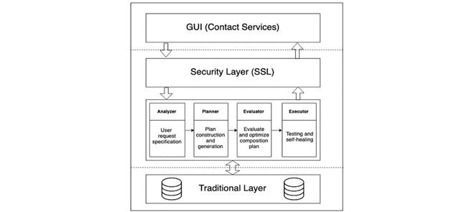

Fig 4.1 System Architecture

System architecture is the procees of designing, describing, and managing the structure and behaviour of complex systems.it is used to ensure that all components of a system work together in an efficient and effective way in he system architecture for predicting accuracy of players in cricket typically involves using machine learning algorithms to analyze players such as ball speed,spin rate,and release point. This data is then used to generate predictions an about a player’s accuracy.

4.2 Data Flow Diagram:
- The DFD is also called as bubble chart. It is a simple graphical formalism that can be used to represent a system in terms of input data to the system, various processing carried out on this data, and the output data is generated by this system.
- The data flow diagram (DFD) is one of the most important modeling tools. It is used to model the system components. These components are the system process, the data used by the process, an external entity that interacts with the system and the information flows in the system.
- DFD shows how the information moves through the system and how it is modified by a series of transformations. It is a graphical technique that depict sin formation flow and the transformations that are applied as data moves from input to output.
- DFD is also known as bubble chart. A DFD may be used to represent a system at any level of abstraction. DFD may be partitioned into levels that represent increasing information flow and functional detail.

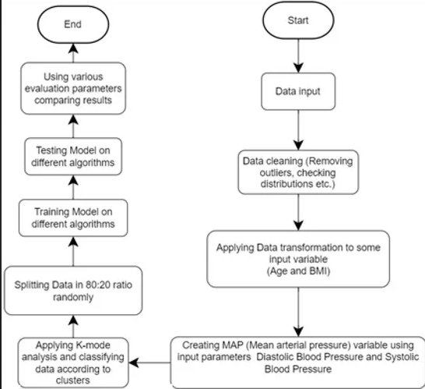
Fig:4.2 Data Flow Diagram

4.3 Unified Modeling Language Design:

UML stands for Unified Modeling Language. UML is a standardized general purpose modeling language in the field of object-oriented software engineering. The standard is managed, and was created by, the Object Management Group.
The goal is for UML to become a common language for creating models of object oriented computer software. In its current form UML is comprised of two major components: a Meta-model and a notation. In the future, some form of method or process may also be added to; or associated with, UML.
The Unified Modeling Language is a standard language for specifying,
Visualization, Constructing and documenting the artifacts of software system, as well as for business modeling and other non-software systems.
The UML represents a collection of best engineering practices that have proven successful in the modeling of large and complex systems.
The UML is a very important part of developing objects oriented software and the software development process. The UML uses mostly graphical notations to express the design of software projects.

- GOALS:
The Primary goals in the design of the UML are as follows:
- Provide users a ready-to-use, expressive visual modeling Language so that they can develop and exchange meaningful models.
- Provide extendibility and specialization mechanisms to extend the core concepts.
- Be independent of particular programming languages and development process.
- Provide a formal basis for understanding the modeling language.
- Encourage the growth of OO tools market.
- Support higher level development concepts such as collaborations, frameworks, patterns and components.
- Integrate best practices.

4.3.1 Use Case Diagram:
A use case diagram in the Unified Modeling Language (UML) is a type of behavioral diagram defined by and created from a Use-case analysis. Its purpose is to present a graphical overview of the functionality provided by a system in terms of actors, their goals (represented as use cases), and any dependencies between those use cases. The main purpose of a use case diagram is to show what system functions are performed for which actor. Roles of the actors in the system can be depicted.

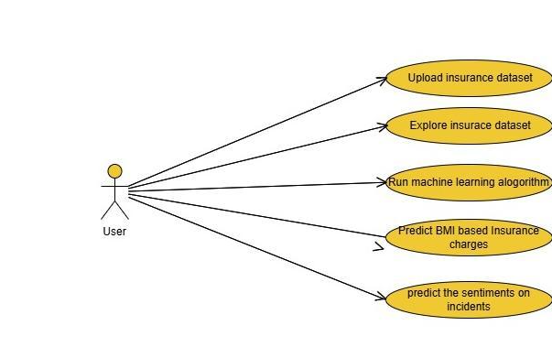

Fig 4.3 Use case Diagram for user
4.3.2 Class Diagram:
A class diagram in the Unified Modeling Language (UML) is a type of static structure diagram that describes the structure of a system by showing the system's classes, their attributes, operations (or methods), and the relationships among the classes. It explains which class contains information.

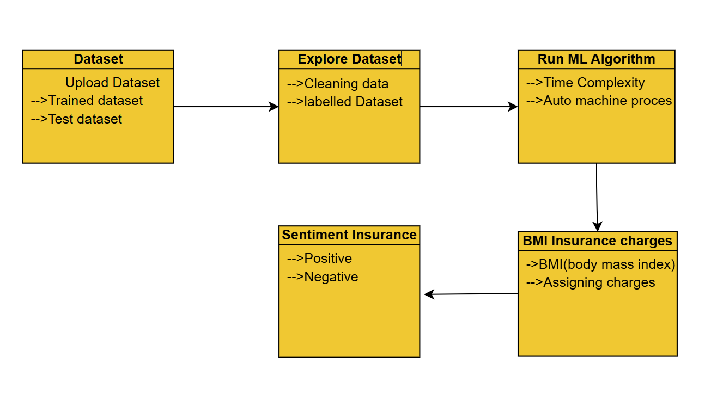
Fig.4.4 Class Diagram for user

4.4. Sequence Diagram:
A sequence diagram in Unified Modeling Language (UML) is a kind of interaction diagram that shows how processes operate with one another and in what order. It is a construct of a Message Sequence Chart. Sequence diagrams are sometimes called event diagrams, event scenarios, and timing diagrams.

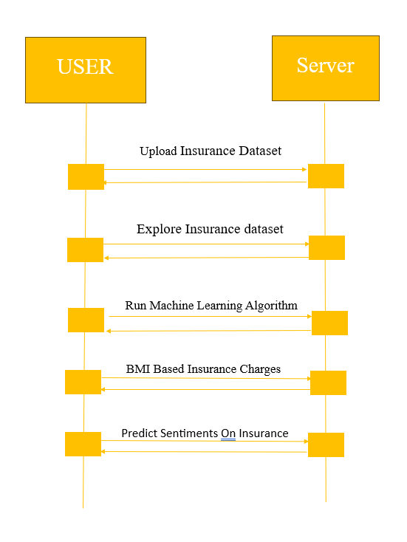
Fig 4.5 Sequence Diagram for user

4.4 Input Design:
The input design is the link between the information system and the user. It comprises the developing specification and procedures for data preparation and those steps are necessary to put transaction data in to a usable form for processing can be achieved by inspecting the computer to read data from a written or printed document or it can occur by having people keying the data directly into the system. The design of input focuses on controlling the amount of input required, controlling the errors, avoiding delay, avoiding extra steps and keeping the process simple. The input is designed in such a way so that it provides security and ease of use with retaining the privacy. Input Design considered the following things:
- What data should be given as input?
- How the data should be arranged or coded?
- The dialog to guide the operating personnel in providing input.
- Methods for preparing input validations and steps to follow when error occur.
Objectives:
- Input Design is the process of converting a user-oriented description of the input into a computer-based system. This design is important to avoid errors in the data input process and show the correct direction to the management for getting correct information from the computerized system.
- It is achieved by creating user-friendly screens for the data entry to handle large volume of data. The goal of designing input is to make data entry easier and to be free from errors. The data entry screen is designed in such a way that all the data manipulates can be performed. It also provides record viewing facilities.
- When the data is entered it will check for its validity. Data can be entered with the help of screens. Appropriate messages are provided as when needed so that the user will not be in maize of instant. Thus the objective of input design is to create an input layout that is easy to follow.
- The context of systems development and information processing are to ensure that the data input process is efficient, accurate, and user-friendly. The main objectives of input design include :

- Accuracy
- Efficiency
- Consistency
- Flexibility
- Security
- Data Integrity
- User Interaction

4.5 Output Design:
A quality output is one, which meets the requirements of the end user and presents the information clearly. In any system results of processing are communicated to the users and to other system through outputs. In output design it is determined how the information is to be displaced for immediate need and also the hard copy output. Efficient and intelligent output design improves the system’s relationship to help user decision-making.
1. Designing computer output should proceed in an organized, well thought out manner; the right output must be developed while ensuring that each output element is designed so that people will find the system can use easily and effectively.
2. Select methods for presenting information.
3. Create document, report, or other formats that contain information produced by the system.
The output form of an information system should accomplish one or more of the following objectives.
  - Convey information about past activities, current status or projections of the
  - Future.
  - Signal important events, opportunities, problems, or warnings.
  - Trigger an action.
  - Confirm an action.
CHAPTER – 5

IMPLEMENTATION

5.1 Machine Learning Technology:
Machine learning is a discipline that deals with programming the systems so as to make them automatically learn and improve with experience. Here, learning implies recognizing and understanding the input data and taking informed decisions based on the supplied data. It is very difficult to consider all the decisions based on all possible inputs. To solve this problem, algorithms are developed that build knowledge from a specific data and past experience by applying the principles of statistical science, probability, logic, mathematical optimization, reinforcement learning, and control theory.
5.2 Steps Involved in Machine Learning:
A machine learning project involves the following steps
  - Defining a Problem
  - Preparing Data
  - Evaluating Algorithms
  - Improving Results

  - Presenting results

Machine Learning (ML) is an automated learning with little or no human intervention. It involves programming computers so that they learn from the available inputs. The main purpose of machine learning is to explore and construct algorithms that can learn from the previous data and make predictions on new input data.The input to a learning algorithm is training data, representing experience, and the output is any expertise, which usually takes the form of another algorithm that can perform a task. The input data to a machine learning system can be numerical, textual, audio, visual, or multimedia.

5.3 Machine Learning vs. Traditional Programming:
Traditional programming differs significantly from machine learning. In traditional programming, programmers code all the rules in consultation with an expert in the industry for which software is being developed. Each rule is based on a logical foundation; the machine will execute an output following the logical statement. When the system grows complex, more rules need to be written. It can quickly become sustainable to maintain.

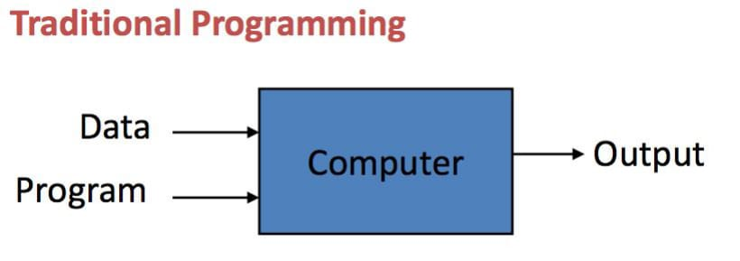
Fig 5.1: Traditional Programming
Machine learning is supposed to overcome this issue. The machine learns how the input and output data are correlated and it writes a rule. The programmers do not need to write new rules each time there is new data. The algorithms adapt in response to new data and experiences to improve efficacy over time.

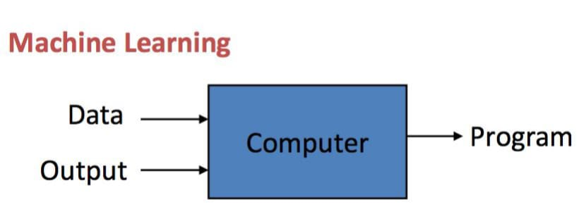

5.2: Machine Learning
5.4 How does Machine learning work?
Machine learning is the brain where all the learning takes place. The way the machine learns is similar to the human being. Humans learn from experience. The more we know, the more easily we can predict. By analogy, when we face an unknown situation, the likelihood of success is lower than the known situation. Machines are trained the same. To make an accurate prediction, the machine sees an example. When we give the machine a similar example, it can figure out the outcome. However, like a human, if it’s feed a previously unseen example, the machine has difficulties to predict.
5.5 Machine learning Algorithms and where they are used?
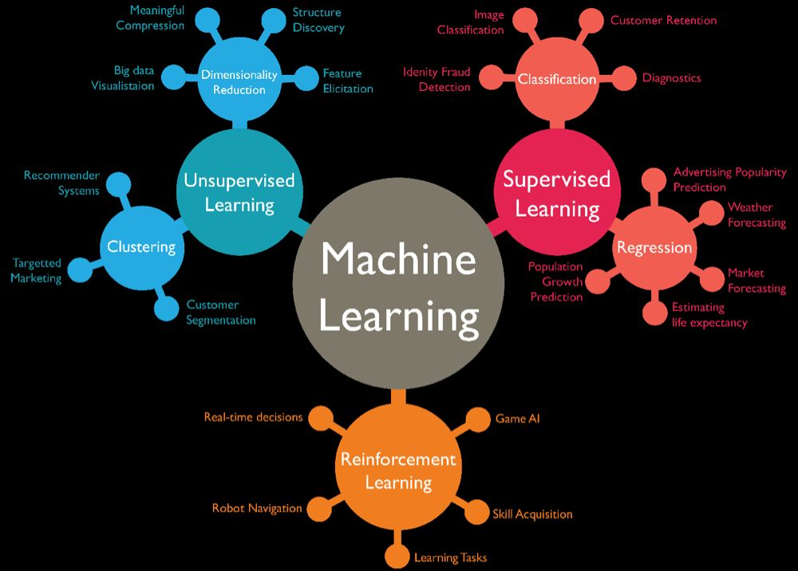
Fig 5.3: Machine Learning Algorithms
5.6 Types of Machine Learning:
There are four categories of machine learning algorithms as shown below
- Supervised learning algorithm
- Unsupervised learning algorithm
- Semi-supervised learning algorithm
- Reinforcement learning algorithm

5.6.1 Supervised Learning:
Supervised learning is commonly used in real world applications, such as face and speech recognition, products or movie recommendations, and sales forecasting. Supervised learning can be further classified into two types - Regression and Classification.
- Regression trains on and predicts a continuous-valued response, for example predicting real estate prices.
- Classification attempts to find the appropriate class label, such as analyzing positive/negative sentiment, male and female persons, benign and malignant tumors, secure and unsecure loans etc.
In supervised learning, learning data comes with description, labels, targets or desired outputs and the objective is to find a general rule that maps inputs to outputs. This kind of learning data is called labeled data. The learned rule is then used to label new data with unknown outputs.

5.6.2 Unsupervised Learning:
Unsupervised learning is used to detect anomalies, outliers, such as fraud or defective equipment, or to group customers with similar behaviors for a sales campaign. It is the opposite of supervised learning. When learning data contains only some indications without any description or labels, it is up to the coder or to the algorithm to find the structure of the underlying data, to discover hidden patterns, or to determine how to describe the data.

5.6.3 Semi-supervised Learning:
If some learning samples are labeled, but some other are not labeled, then it is semi-supervised learning. It makes use of a large amount of unlabeled data for training and a small amount of labeled data for testing. Semi-supervised learning is applied in cases where it is expensive to acquire a fully labeled dataset while more practical to label a small subset.
5.6.4 Reinforcement Learning:
Here learning data gives feedback so that the system adjusts to dynamic conditions in order to achieve a certain objective. The system evaluates its performance based on the feedback responses and reacts accordingly.
5.7 Challenges and Limitations of Machine learning:

The primary challenge of machine learning is the lack of data or the diversity in the dataset. A machine cannot learn if there is no data available. Besides, a dataset with a lack of diversity gives the machine a hard time. A machine needs to have heterogeneity to learn meaningful insight. It is rare that an algorithm can extract information when there are no few variations. This constant leads to poor evaluation and prediction.

5.8 Application of Machine learning :
1.Augmentation:
Machine learning, which assists humans with their day-to-day tasks, personally or commercially without having complete control of the output.
2.Automation:
Machine learning, which works entirely autonomously in any field without the need for any human intervention.
3.Finance Industry:
Machine learning is growing in popularity in the finance industry. Banks are mainly using ML to find patterns inside the data but also to prevent fraud.
4.Government Organization:
The government makes use of ML to manage public safety and utilities. Take the example of China with the massive face recognition.
5.Marketing:Broad use of AI is done in marketing thanks to abundant access data. Before the age of mass data, researchers develop advanced mathematical tools like Bayesian analysis to estimate the value of person.

- Why is Machine Learning important?
Machine learning is the best tool so far to analyze, understand and identify a pattern in the data. One of the main ideas behind machine learning is that the computer can be trained to automate tasks that would be exhaustive or impossible for a human being. The clear breach from the traditional analysis is that machine learning can take decisions with minimal human intervention.
- Python:
Python is a general-purpose interpreted, interactive, object-oriented, and high-level programming language. An interpreted language, Python has a design philosophy that emphasizes code readability (notably using whitespace indentation to delimit code blocks rather than curly brackets or keywords), and a syntax that allows programmers to express concepts in fewer lines of code than might be used in languages such as C++or Java. It provides constructs that enable clear programming on both small and large scales. Python interpreters are available for many operating systems. Python, the reference implementation of Python, is open source software and has a community-based development model, as do nearly all of its variant implementations. C,Python is managed by the non-profit Python Software Foundation. Python features a dynamic type system and automatic memory management.
It supports multiple programming paradigms, including object oriented, imperative, and functional and has a large and comprehensive standard library.
5.9 Python libraries for machine learning:
- NumPy:
NumPy is a library for the Python programming language, adding support for large, multi-dimensional arrays and matrices, along with a large collection of high-level mathematical functions to operate on these arrays. The core functionality of NumPy is its "ndarray", for n-dimensional array, data structure. These arrays are strided views on memory. In contrast to Python's built-in list data structure, these arrays are homogeneously typed: all elements of a single array must be of the same type.
- Pandas:
Pandas is the most popular python library that is used for data analysis. It provides highly optimized performance with back-end source code is purely written in C or Python. We can analyze data in pandas with Series and Data Frames.
- Matplotlib:
Matplotlib is a python library used to create 2D graphs and plots by using python scripts. It has a module named pyplot which makes things easy for plotting by providing feature to control line styles, font properties, formatting axes etc. It supports a very wide variety of graphs and plots namely histogram, bar charts, power spectra, error charts etc. It is used along with NumPy to provide an environment that is an effective open source alternative for MatLab. It can also be used with graphics toolkits like PyQt and wxPython.
- Scikit-learn:
Scikit-learn is a machine learning library for Python. It features several regression, classification and clustering algorithms including SVMs, gradient boosting, k-means, random forests and DBSCAN. Scikit is written in Python (most of it) and some of its core algorithms are written in Cython for even better performance. Scikit-learn is used to build models and it is not recommended to use it for reading, manipulating and summarizing data as there are better frameworks available for the purpose. It is open source and released under BSD license.
- Sea-born:
Seaborn is an open source, BSD-licensed Python library providing high level API for visualizing the data using Python programming language. Data can be visualized by representing it as plots which is easy to understand, explore and grasp. Such data helps in drawing the attention of key elements. To analyze a set of data using Python, we make use of Matplotlib, a widely implemented 2D plotting library. Likewise, Seaborn is a visualization library in Python. It is built on top of Matplotlib.

5.10 Uses of Python :
Applications:
Python can be used to develop different applications like web applications, graphic user interface based applications, software development application, scientific and numeric applications, network programming, Games and 3D applications and other business applications. It makes an interactive interface and easy development of applications.
- Multiple Programming paradigms:
Python is also used because of its providing continuous support to several programming paradigms. As it supports object-oriented programming and structured programming. Python has features, which also support various concepts of functional programming language. It is used for dynamic type system and automatic memory management. Python language features and programming paradigms allow you for developing the small as well as large applications. It can be used for complex software applications.
- Robust Standard Library:
Python has a large and robust standard library to use for developing the applications. It also makes the developers use Python over other languages. The standard library helps in using the different range of modules available for Python. As this module helps you in adding the functionality without writing any more code. To get the information about various modules, documentation on python standard library can be referred. While developing any web application, implementing web services, performing string operations and other usages like interface protocol, the standard library documentation helps.
- Compatible with Major Platforms and Systems:
Python is mainly compatible with major platforms and systems because of which it is used mainly for developing applications. With help of python interpreters, python code can be run on specific platforms and tools as it supports many operating systems. As python is an interpreted high-level programming language and it allows you to run the code on multiple platforms.
The new and modified code can be executed without recompiling and its impact can be monitored or checked. It means it’s not required to recompile the code after every change. This feature helps in saving the development time of the developers.
- Access of Database:
Uses of Python also helps in accessing the database easily. Python helps in customizing the interfaces of different databases like MySQL, Oracle, Microsoft SQL Server, PostgreSQL, and other databases. It has an object database like Durus and ZODB.
It is used for standard database API and freely available for download.
- Code Readability:
Python code is easy to read and maintained. It is easily reusable as well wherever it is required. Python’s having simple syntax, which allows the different concepts to develop without writing any additional code. The code should be of good quality and easy to maintain the source code and simplify the maintenance, which is required to develop the software application. It also emphasizes code readability, which is the great feature, unlike other programming languages. It helps in building custom applications and clean code helps in maintaining and updating the software applications without putting extra effort on the same code.
- Simplify Complex Software Development:
Applications of Python is used to simplifying the complex software development process as it is a general-purpose programming language. It is used for developing the complex application like scientific and numeric application, and for both desktop and web applications. Python has features like analyzing data and visualization, which helps in creating custom solutions without putting extra effort and time. It helps you to visualize and present data in an effective way.
- Many Open Source Frameworks and Tools:

Python is open source and easily available. This also helps in costing the software development significantly. There are many open source applications of python frameworks, libraries, and development tools for developing the application without putting extra cost. Python frameworks simplify and make the process faster for web application development and the frameworks are Django, Flask, pyramid etc. Python GUI frameworks are available for developing the GUI based application.

8. Adopt Test Driven Development:
Python makes coding easier as well as testing with help of adopting Test Driven Development approach. The test cases can be easily written before any code development. Whenever the code development started, the written test cases can start testing the code simultaneously and provides the result. These can also be used for checking or testing the pre-requirements based on the source code.
Other applications for which python is used:
There are other applications for which python is used that are Robotics, web scraping, scripting, artificial intelligence, data analysis, machine learning, face detection, color detection, 3D CAD applications, console-based applications, audio-based applications, video-based applications, enterprise applications, and applications for Images etc. These are some major applications used.
5.11 Neural network:
In a machine learning algorithm, which is built on the principle of the organization and functioning of biological neural networks. This concept arose in an attempt to simulate the processes occurring in the brain by Warren McCulloch and Walter Pitts in 1943.
Neural networks consist of individual units called neurons. Neurons are located in a series of groups -layers
Neurons in each layer are connected to neurons of the next layer. Data comes from the input layer to the output layer along these compounds.
Each individual node performs a simple mathematical calculation. Тhen it transmits its data to all the nodes it is connected to.
The last wave of neural networks came in connection with the increase in computing power and the accumulation of experience.
That brought Deep learning, where technological structures of neural networks have become more complex and able to solve a wide range of tasks that could not be effectively solved before. Image classification is a prominent.

5.12 Sample Code:
from tkinter import messagebox
from tkinter import *
from tkinter import simpledialog
import tkinter
from tkinter import filedialog
import matplotlib.pyplot as plt
from tkinter.filedialog import askopenfilename
from sklearn.model_selection import train_test_split
from sklearn.linear_model import LinearRegression
import os
from sklearn.metrics import accuracy_score
import numpy as np
import pandas as pd
from vaderSentiment.vaderSentiment import SentimentIntensityAnalyzer
import seaborn as sns

main = tkinter.Tk()
main.title("AUTOMATING E-GOVERNMENT SERVICES WITH MACHINE LEARNING AND ARTIFICIAL INTELLIGENCE")
main.geometry("1300x1200")

global dataset_file
global train_features, label_features
global machine_learning
global data
global X_train, X_test, y_train, y_test

def loadData():
global dataset_file
global data
dataset_file = filedialog.askopenfilename(initialdir="insurance_dataset")
pathlabel.config(text=dataset_file)
text.delete('1.0', END)
text.insert(END,dataset_file+" insurance dataset loaded\n\n")
data = pd.read_csv(dataset_file)
text.insert(END,str(data.head()))

def exploreData():
global data
global train_features, label_features
global X_train, X_test, y_train, y_test
text.delete('1.0', END)

data['sex'] = data['sex'].apply({'male':0, 'female':1}.get)
data['smoker'] = data['smoker'].apply({'yes':1, 'no':0}.get)
data['region'] = data['region'].apply({'southwest':1, 'southeast':2, 'northwest':3, 'northeast':4}.get)
text.insert(END,str(data.head())+"\n\n")

data1 = data.values
train_features = data1[:,0:data.shape[1]-1]
label_features = data1[:,data.shape[1]-1]
X_train, X_test, y_train, y_test = train_test_split(train_features, label_features, test_size = 0.2, random_state = 0)

text.insert(END,"Total records in dataset : "+str(len(train_features))+"\n")
text.insert(END,"80% dataset records used to train ML : "+str(len(X_train))+"\n")
text.insert(END,"20% dataset records used to test ML Accuracy : "+str(len(X_test))+"\n")

sns.jointplot(x=data['age'],y=data['charges'])
plt.show()

def runML():
global X_train, X_test, y_train, y_test
global machine_learning
text.delete('1.0', END)
cls = LinearRegression()
cls.fit(X_train, y_train)
predict = cls.predict(X_test)
#acc = accuracy_score(predict,y_test)
text.insert(END,"Linear Regression Machine Learning Model Generated\n")
machine_learning = cls

def predictPolicy():
text.delete('1.0', END)
global machine_learning

dataset_file1 = filedialog.askopenfilename(initialdir="insurance_dataset")
data1 = pd.read_csv(dataset_file1)
data1['sex'] = data1['sex'].apply({'male':0, 'female':1}.get)
data1['smoker'] = data1['smoker'].apply({'yes':1, 'no':0}.get)
data1['region'] = data1['region'].apply({'southwest':1, 'southeast':2, 'northwest':3, 'northeast':4}.get)
data1 = data1.values
predict = machine_learning.predict(data1)
for i in range(len(data1)):
text.insert(END,str(data1[i])+" Insurance Charges Predicted As : "+str(predict[i])+"\n\n")

def exitSystem():
main.destroy()

def predictSentiments():
text.delete('1.0', END)
sentiment = SentimentIntensityAnalyzer()
review = simpledialog.askstring("Enter your review on insurance policy and charges", "Please enter your reviews on insurance policy and charges", parent=main)

sentiment_dict = sentiment.polarity_scores(review)
opinion = ''
if sentiment_dict['compound'] >= 0.05 :
opinion = 'Positive'
elif sentiment_dict['compound'] <= - 0.05 :
opinion = 'Negative'
else :
opinion = 'Neutral'
text.insert(END,"Your Review : "+review+"\n\n")
text.insert(END,"Predicted Sentiment on your insurance review : "+opinion+"\n")

font = ('times', 16, 'bold')
title = Label(main, text='AUTOMATING E-GOVERNMENT SERVICES WITH MACHINE LEARNING AND ARTIFICIAL INTELLIGENCE')
title.config(bg='brown', fg='white')
title.config(font=font)
title.config(height=3, width=120)
title.place(x=0,y=5)

font1 = ('times', 13, 'bold')
uploadButton = Button(main, text="Upload Insurance Dataset", command=loadData)
uploadButton.place(x=50,y=100)
uploadButton.config(font=font1)

pathlabel = Label(main)
pathlabel.config(bg='brown', fg='white')
pathlabel.config(font=font1)
pathlabel.place(x=460,y=100)

exploreButton = Button(main, text="Explore Insurance Dataset", command=exploreData)
exploreButton.place(x=50,y=150)
exploreButton.config(font=font1)

mlButton = Button(main, text="Run Machine Learning Algorithm", command=runML)
mlButton.place(x=380,y=150)
mlButton.config(font=font1)

predictButton = Button(main, text="Predict BMI Based Insurance Charges", command=predictPolicy)
predictButton.place(x=680,y=150)
predictButton.config(font=font1)

sentimentButton = Button(main, text="Predict Sentiments On Insurance", command=predictSentiments)
sentimentButton.place(x=50,y=200)
sentimentButton.config(font=font1)

exitButton = Button(main, text="Close Here", command=exitSystem)
exitButton.place(x=380,y=200)
exitButton.config(font=font1)

font1 = ('times', 12, 'bold')
text=Text(main,height=20,width=150)
scroll=Scrollbar(text)
text.configure(yscrollcommand=scroll.set)
text.place(x=10,y=250)
text.config(font=font1)

main.config(bg='green')
main.mainloop(
CHAPTER-6
TESTING
6.1 Introduction
The purpose of testing is to discover errors. Testing is the process of trying to discover every conceivable fault or weakness in a work product. It provides a way to check the functionality of components, sub assemblies, assemblies and/or a finished product It is the process of exercising software with the intent of ensuring that the Software system meets its requirements and user expectations and does not fail in an unacceptable manner. There are various types of test. Each test type addresses a specific testing requirement.
  - Types of tests

- Unit testing:
Unit testing involves the design of test cases that validate that the internal program logic is functioning properly, and that program inputs produce valid outputs. All decision branches and internal code flow should be validated. It is the testing of individual software units of the application .it is done after the completion of an individual unit before integration. This is a structural testing, that relies on knowledge of its construction and is invasive. Unit tests perform sic tests at component level and test a specific business process, application, and/or system configuration. Unit tests ensure that each unique path of a business process performs accurately to the

documented specifications and contains clearly defined inputs and expected results.
- Integration testing:
Integration tests are designed to test integrated software components to determine if they actually run as one program. Testing is event driven and is more concerned with the basic outcome of screens or fields.
Integration tests demonstrate that although the components were individually satisfaction, as shown by successfully unit testing, the combination of components is correct and consistent. Integration testing is specifically aimed at exposing the problems that arise from the combination of components.

- Functional test:
Functional tests provide systematic demonstrations that functions tested are available as specified by the business and technical requirements, system documentation, and user manuals.
Functional testing is centered on the following items:

Valid Input | : | identified classes of valid input must be accepted.
Invalid Input | : | identified classes of invalid input must be rejected.
Functions Output | : | identified functions must be exercised.

Systems/Procedures :

interfacing systems or procedures must be invoked.
Organization and preparation of functional tests is focused on requirements, key functions, or special test cases. In addition, systematic coverage pertaining to identify Business process flows; data fields, predefined processes, and successive processes must be considered for testing. Before functional testing is complete, additional tests are identified and the effective value of current tests is determined.
- System Test:

System testing ensures that the entire integrated software system meets requirements. It tests a configuration to ensure known and predictable results. An example of system testing is the configuration oriented system integration test. System testing is based on process descriptions and flows, emphasizing pre-driven process links and integration points.

- White Box Testing:

White Box Testing is a testing in which in which the software tester has knowledge of the inner workings, structure and language of the software, or at least its purpose. It is purpose. It is used to test areas that cannot be reached from a black box level.

- BlackBox Testing:
Black Box Testing is testing the software without any knowledge of the inner workings, structure or language of the module being tested. Black box tests, as most other kinds of tests, must be written from a definitive source document, such as specification or requirements document, such as specification or requirements document. It is a testing in which the software under test is treated, as a black box .you cannot “see” into it. The test provides inputs and responds to outputs without considering how the software works.
6.3 Test Cases:
All the test cases mentioned above passed successfully.

Test  Id | Test Case Name | Input | Expected Output | Obtained  Output | Result
1. | Upload Insurance data set | Uploading Insurance dataset from folder | Dataset loaded | Dataset loaded Normal “Insurance” | Success
2. | Explore Insurance dataset Image | Exploring Insurance Dataset Image | Dataset Loaded Image | Dataset XandY arrays are saved | Success
3. | Run Machine Learing Algorithm | Generating ML Algorithm | ML Algorithm Generated | Linear regression machine learning model generated | Success
4. | Predict BMI based insurance charges | Generating insurance charges | Predicted Insurance Charges | Insurance charge predicted as :  31468.95938829868 | Success
5. | Predicts sentiments on insurance | Generating policy is good with less charges and more coverage | Positive predict sentiments | Predicted sentiment on your insurance review : Positive | Success

Tab: 6.1 Test case Specifications
6.4 Test Results:
All the test cases mentioned above passed successfully. No defects encountered.
User Acceptance Testing is a critical phase of any project and requires significant participation by the end user. It also ensures that the system meets the functional requirements.

CHAPTER– 7

SAMPLE SCREENS

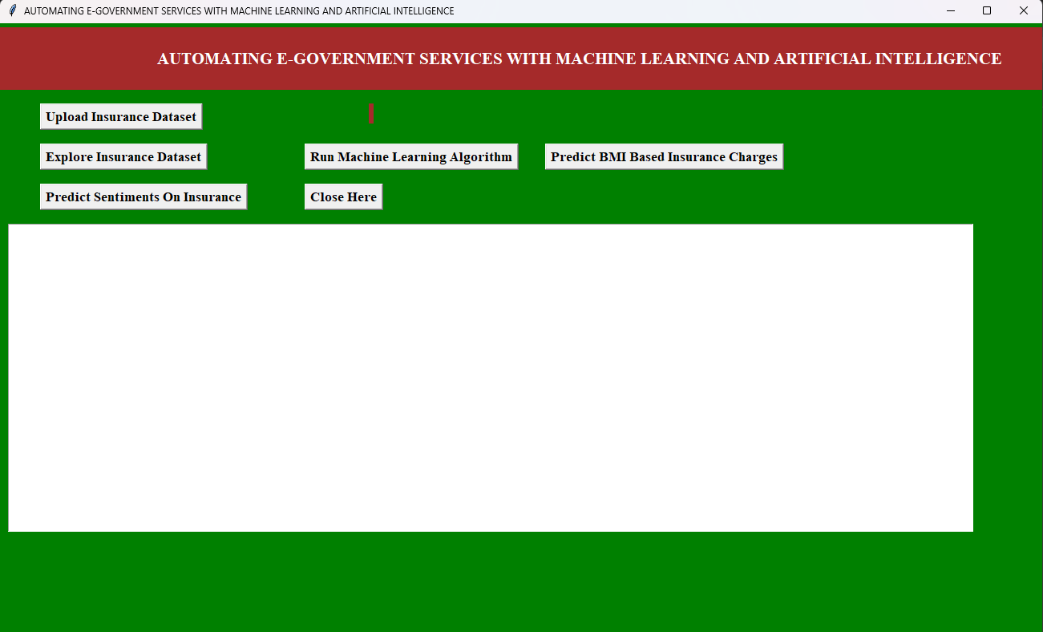

Fig 7.1: Home page of a Automatic E-government services with
Machine learning and Artificial Intelligence

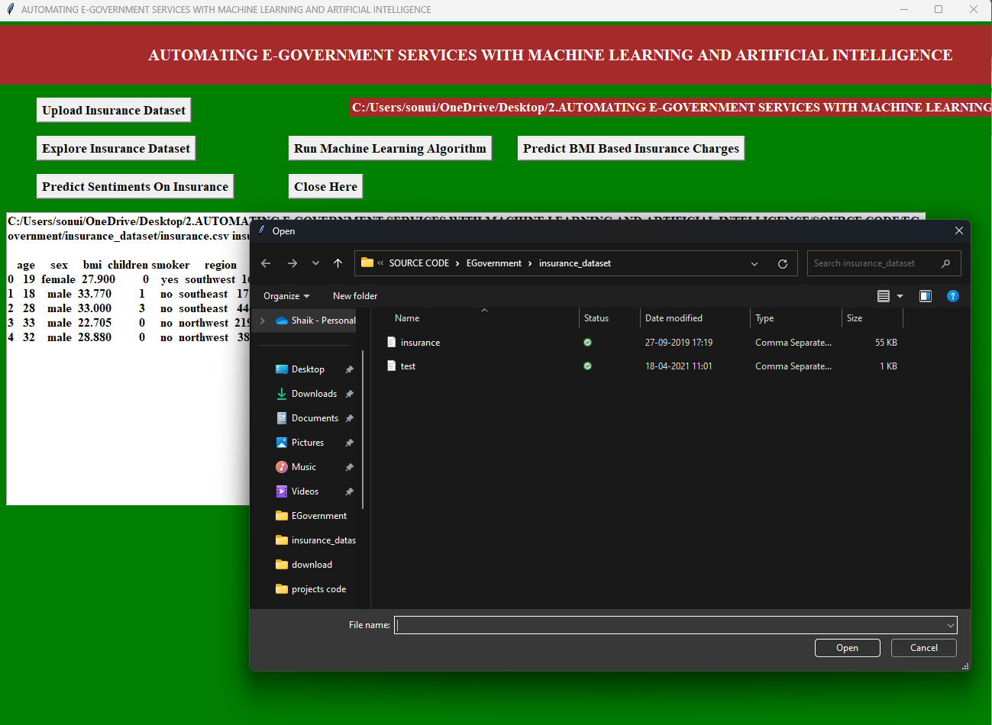
Fig 7.2: uploading datasets(Normal/Insurance)
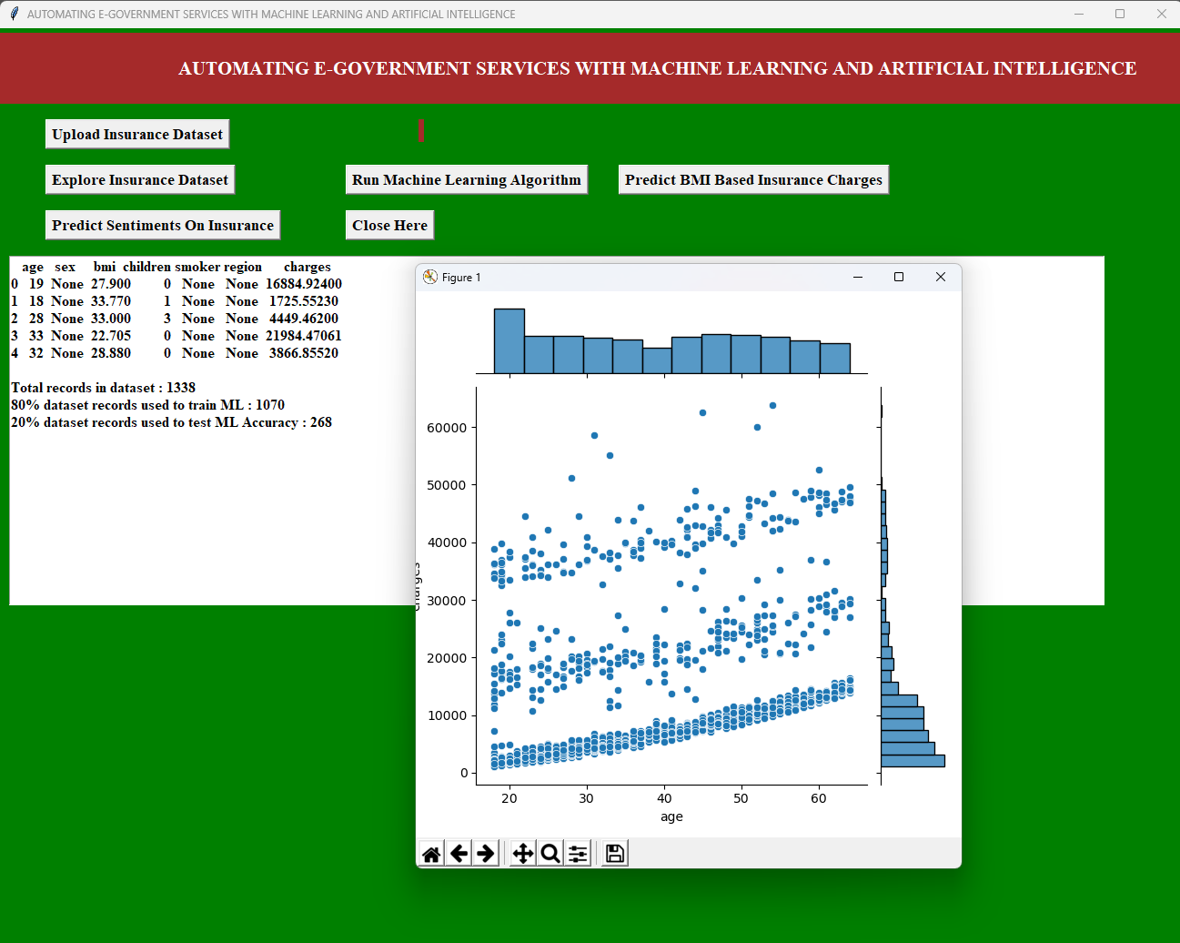
Fig 7.3: Explore Insurance Dataset
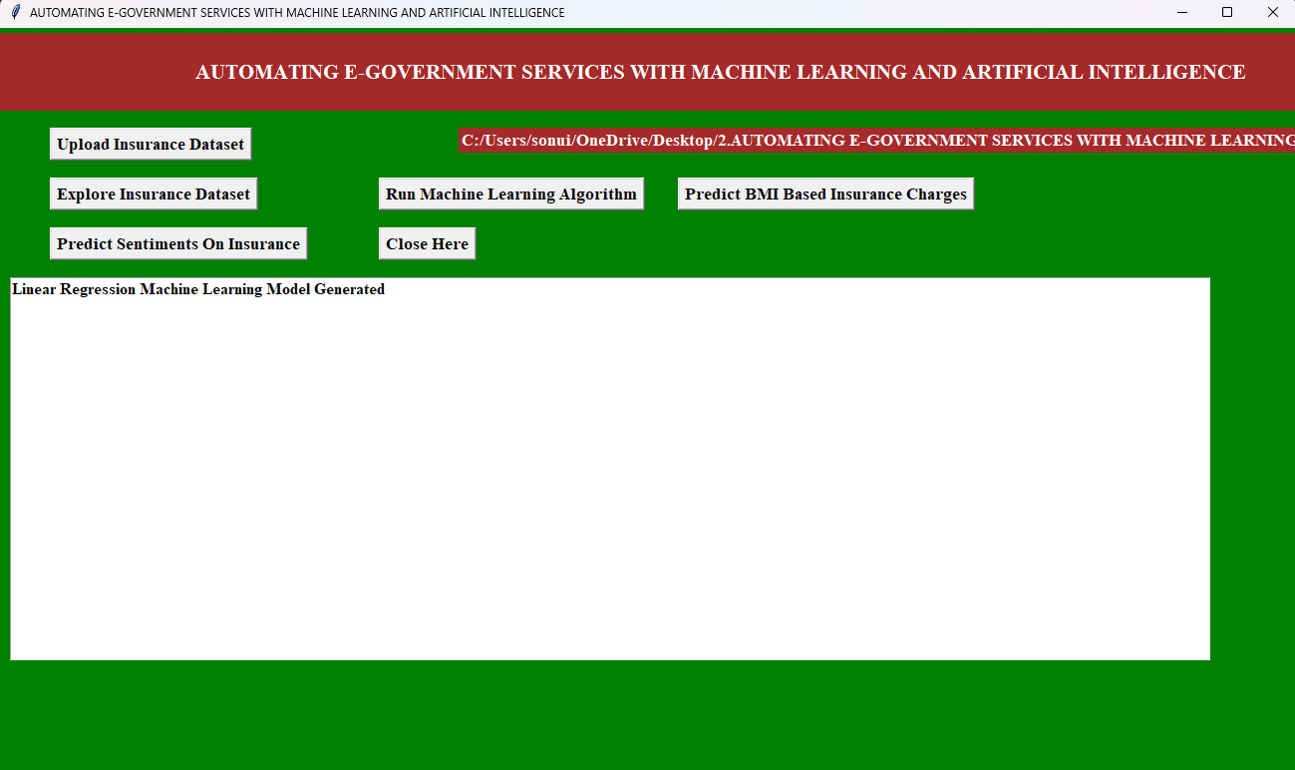
Fig 7.4 : Generating Machine Learning Model
A
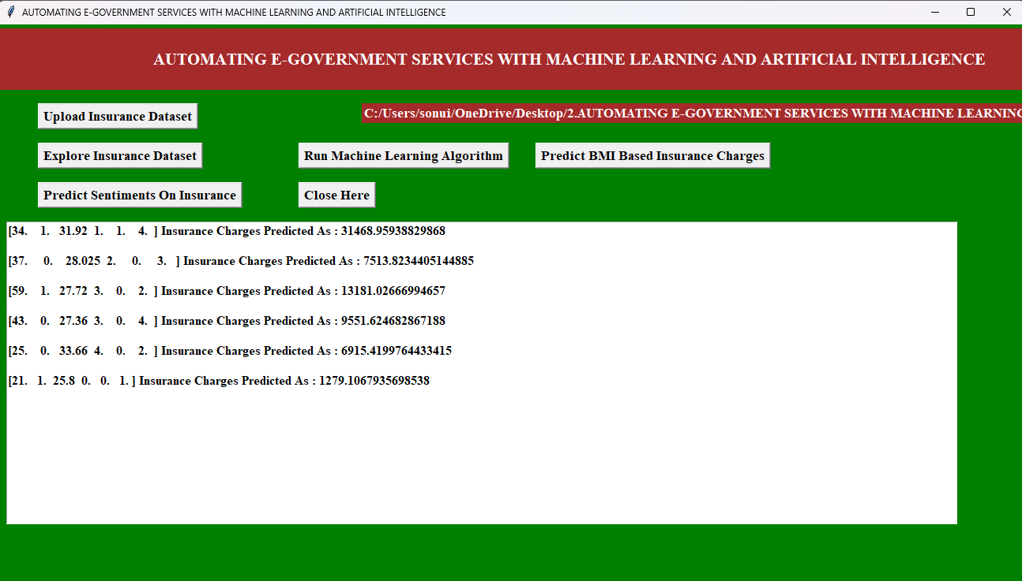
Fig 7.5: Predict BMI based Insurance Charges
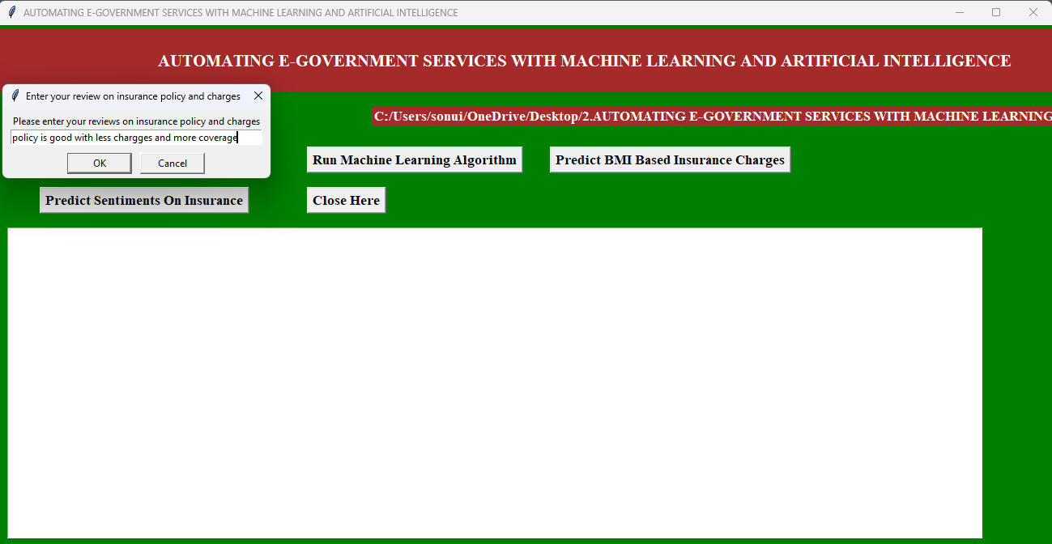

Fig 7.6 : Review of predict sentiments on insurance
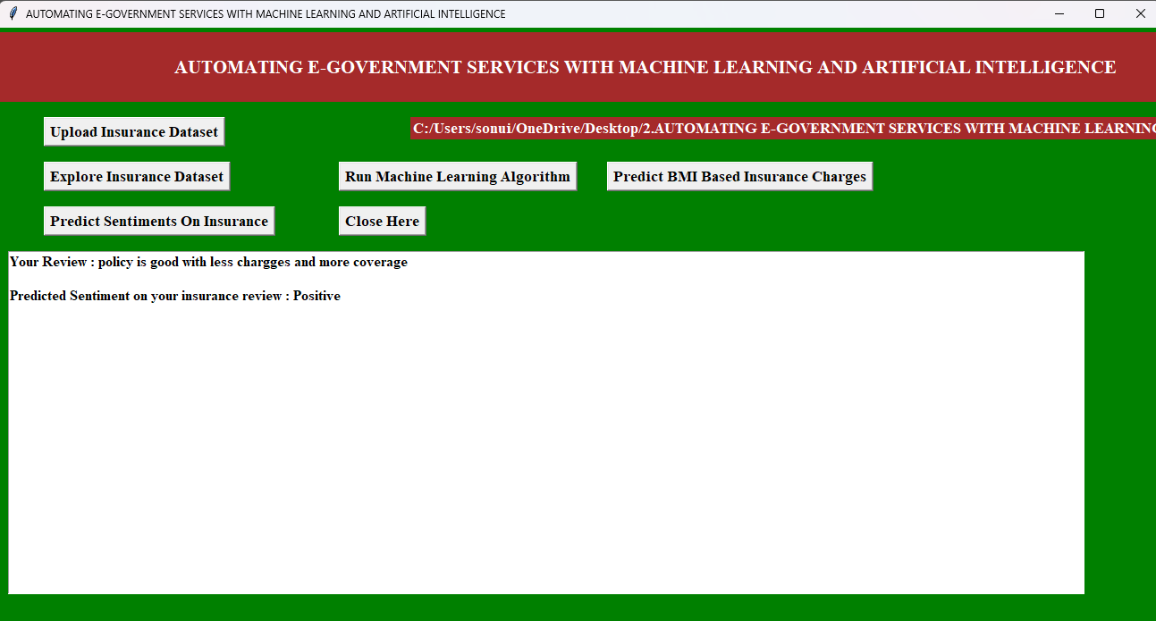

Fig 7.7 : Predict Sentiments on Insurance

CHAPTER – 8

CONCLUSION
Recent advances in AI and deep learning technologies more government agencies are starting to use such technologies to improve their systems and services. A large set of challenges hinder the adoption of such technologies including the lack of experts computational resources, trust & AI interpretability. The overarching goal of introducing new frame works and platform to recent advances in AI techniques in the government systems & services to improve the overall trust, transparency & efficiency of e-government. Ultimately, AI and ML represent the future of smart, automated governance, offering the potential to not only improve operational efficiency but also build more citizen-centric, transparent, and inclusive public services. The challenge lies in implementing these technologies responsibly, ensuring that the benefits of automation are widely shared and aligned with the public good.

CHAPTER - 9
FUTURE ENHANCEMENT

The integration of AI and ML into e-government services has the potential to significantly improve service delivery, increase efficiency, and foster a more transparent and responsive government. As these technologies evolve, they will play a pivotal role in shaping the future of public administration, offering smarter, more adaptive systems that cater to the diverse needs of citizens while driving innovation in governance. Here are several key ways in which ML and AI can contribute to the evolution of e-government services:

- Personalized citizen services
- Enhanced public security and fraud detection
- Improved public service delivery
- Enhanced decision making & data governance
- Smart health care services
- Digital identity and E-voting
- Citizen engagement & trust.

CHAPTER - 10
BIBLIOGRAPHY
Books Referred :
- Object Oriented Software Engineering: using UML, patterns and java, brooch
- The UML user guide – Grady Brooch
- Think Python-Allen Downey, Green Tea Press.
- Python Programming-
- W.Chun, Pearson
REFERENCES
- K. He, X. Zhang, S. Ren, and J. Sun, ``Deep residual learning for image recognition,'' in Proc. IEEE Conf. Compute. Vis. Pattern Recognit., Jun. 2016, pp. 770_778.

- Y.-D. Zhang, Y. Zhang, X.-X. Hou, H.Chen, and S.-H.Wang,“Sevenlayer deep neural network based on sparse autoencoder for voxelwise detection of cerebral microbleed,” Multimedia Tools Appl.,vol.77,no.9,pp. 10521_10538, May 2018.

- S. Venugopalan, H.Xu,J. Donahue, M. Rohrbach, R. Mooney, and K. Saenko, “Translating videos to natural language using deep recurrent neural networks,'' 2014, arXiv:1412.4729.

- C. Bishop, Pattern Recognition and Machine Learning. New York, NY, USA: Springer, 2006.

